**Flight Price Prediction systems**

**Submited by,**

**Kanagavalli T**

**Computer Scince**

**1.INTRODUCTION**

**People who work frequently travel through flight will have better knowledge on best discount and right time to buy the ticket. For the business purpose many airline companies change prices according to the seasons or time duration. They will increase the price when people travel more. Estimating the highest prices of the airlines data for the route is collected with features such as Duration, Source, Destination, Arrival and Departure. Features are taken from chosen dataset and in the price wherein the airline price ticket costs vary overtime. we have implemented flight price prediction for users by using KNN, decision tree and random forest algorithms. Random Forest shows the best accuracy of 80% for predicting the flight price. also, we have done correlation tests and metrics for the statistical analysis.**

* 1. **OVERVIEW**

**The business requirements for a machine learning model to predict personal loan approval include the ability to accurately predict loan approval based on applicant information, Minimise the number of false positives (approved loans that default) and false negatives (rejected loans that would have been successful). Provide an explanation for the model's decision, to comply with regulations and improve transparency.**

**2.1 LITERATURE SURVEY**

**As the data is increasing daily due to digitization in the banking sector, people want to apply for loans through the internet. Machine Learning (ML), as a typical method for information investigation, has gotten more consideration increasingly. Individuals of various businesses are utilising ML calculations to take care of the issues dependent on their industry information. Banks are facing a significant problem in the approval of the loan. Daily there are so many applications that are challenging to manage by the bank employees, and also the chances of some mistakes are high.Most banks earn profit from the loan, but it is risky to choose deserving customers from the number of applications.There are various algorithms that have been used with varying levels of success. Logistic regression, decision tree, random forest, and neural networks have all been used and have been able to accurately predict loan defaults. Commonly used features in these studies include credit score, income, and employment history, sometimes also other features like age, occupation, and education level.**

**3.1 THEORITICAL ANALYSIS**

**This project is to use machine learning techniques to model the behaviour of flight prices prices**

**Over the time predict the price of the flight-ticket.**

**To study how airline ticket changes over time,extract the factors that influence these functions and describe how they’re correlated**

**3.2 HARDWARE / SOFTWARE DESIGNING**

**The hardware require for the development of this project is:**

**Processor :Intel CoreTM i5-9300H**

**Processor speed :2.4GHz**

**RAM Size :8 GB DDR**

**System Type :X64-based processor**

**SOFTWARE DESIGNING:**

**The software required for the development of this project is:**

**DestopGUI :Anaconda Navigator**

**Operating system :Windows 10**

**Programming :PYTHON**

**Technical Architecture:**

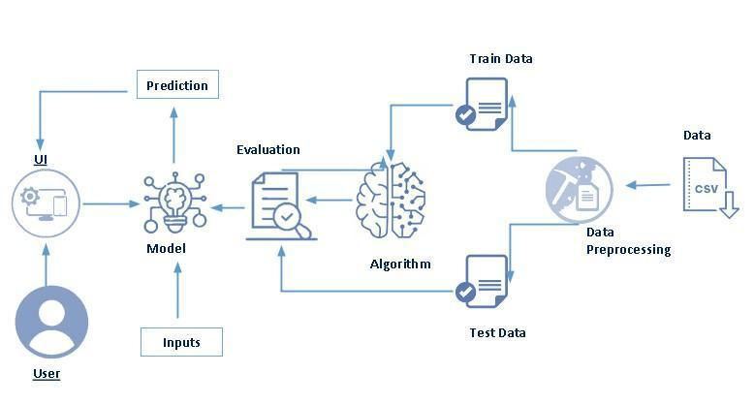

**Project Flow:**

* **User interacts with the UI to enter the input.**
* **Entered input is analysed by the model which is integrated.**
* **Once model analyses the input the prediction is showcased on the UI**

**To accomplish this, we have to complete all the activities listed below,**

**Define Problem / Problem Understanding**

* **Specify the business problem**
* **Business requirements**
* **Literature Survey**
* **Social or Business Impact.**

**Data Collection & Preparation**

* **Collect the dataset**
* **Data Preparation**

**Exploratory Data Analysis**

* **Descriptive statistical**
* **Visual Analysis**

**Model Building**

* **Training the model in multiple algorithms**
* **Testing the model**

**Performance Testing & Hyperparameter Tuning**

* ***Testing model with multiple evaluation metrics***
* **Comparing model accuracy before & after applying hyperparameter tuning**

**Model Deployment**

* **Save the best model**
* **Integrate with Web Framework**

**Project Demonstration & Documentation**

* **Record explanation Video for project end to end solution**
* **Project Documentation-Step by step project development procedure**
* **We are building a flask application which needs HTML pages stored in the templates folder and a python script app.py for scripting.**
* **model1.pkl is our saved model. Further we will use this model for flask integration.**
* **Training folder contains model training files and training_ibm folder contains IBM deployment files**

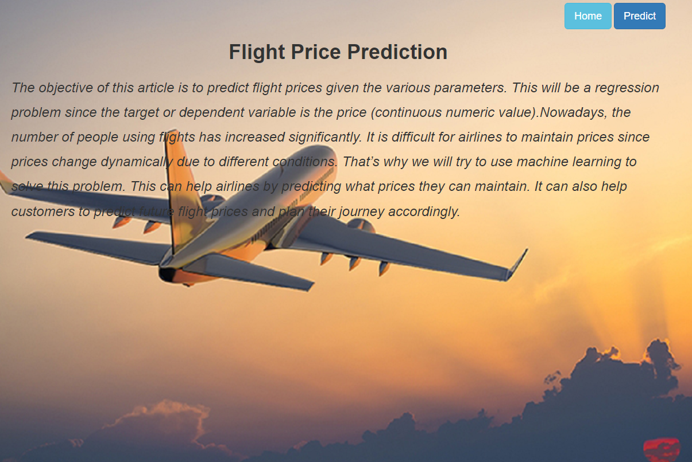

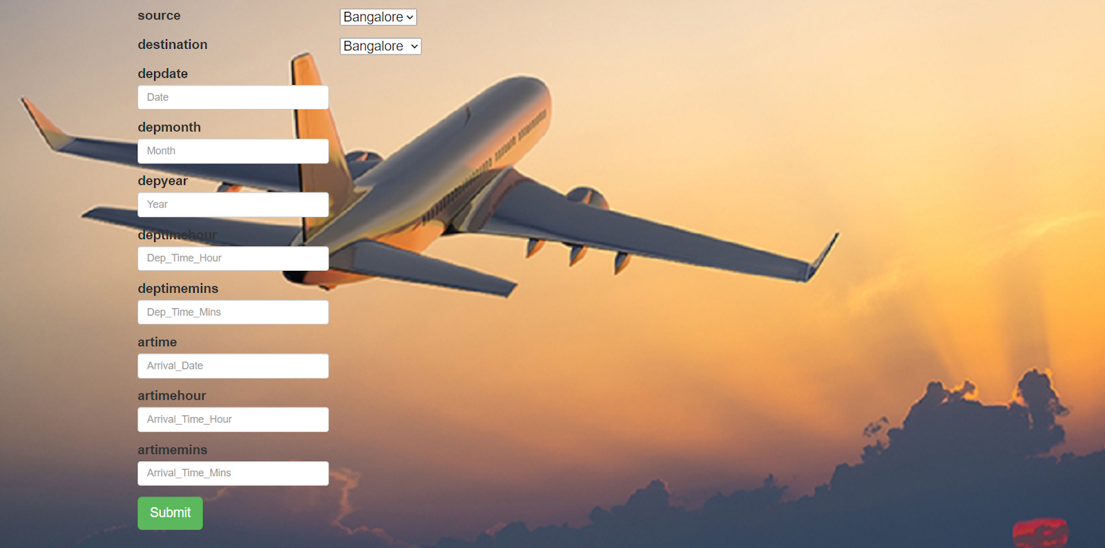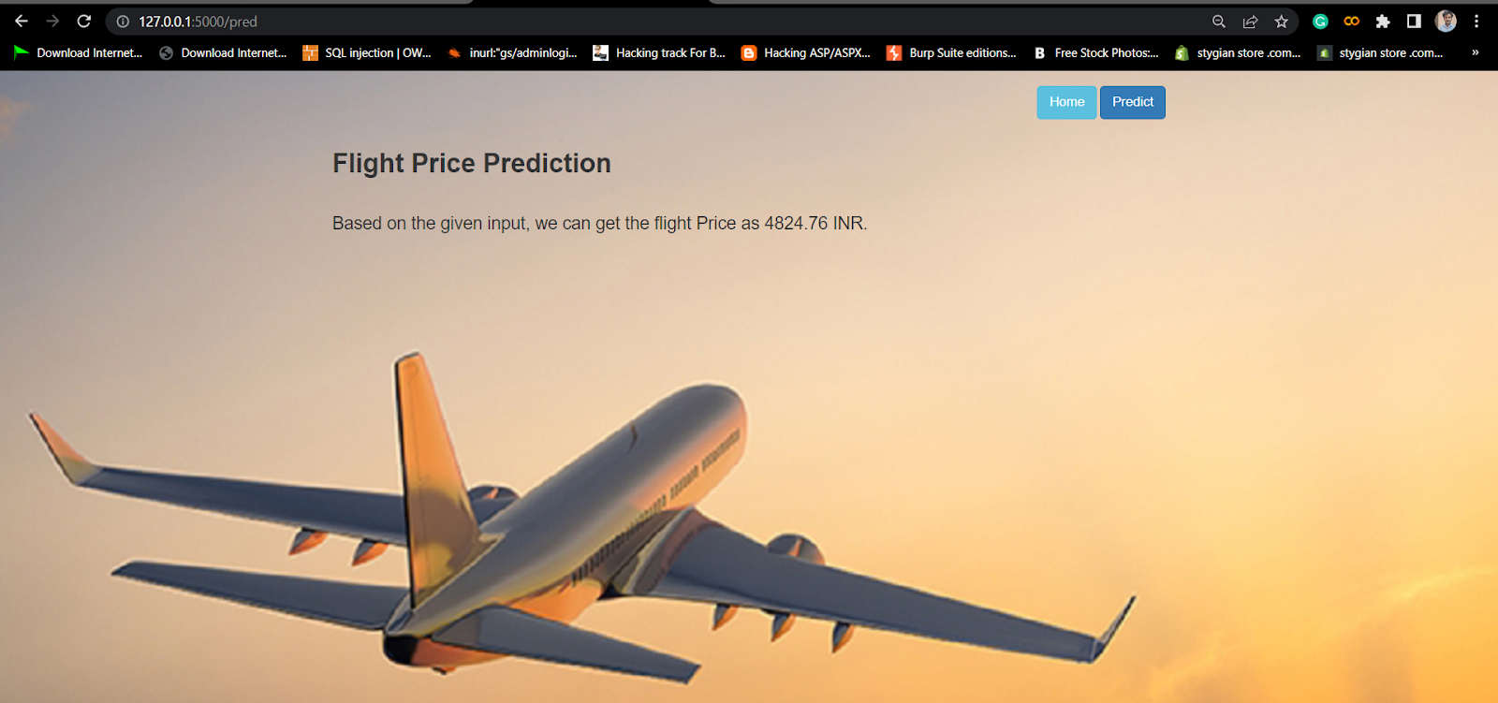

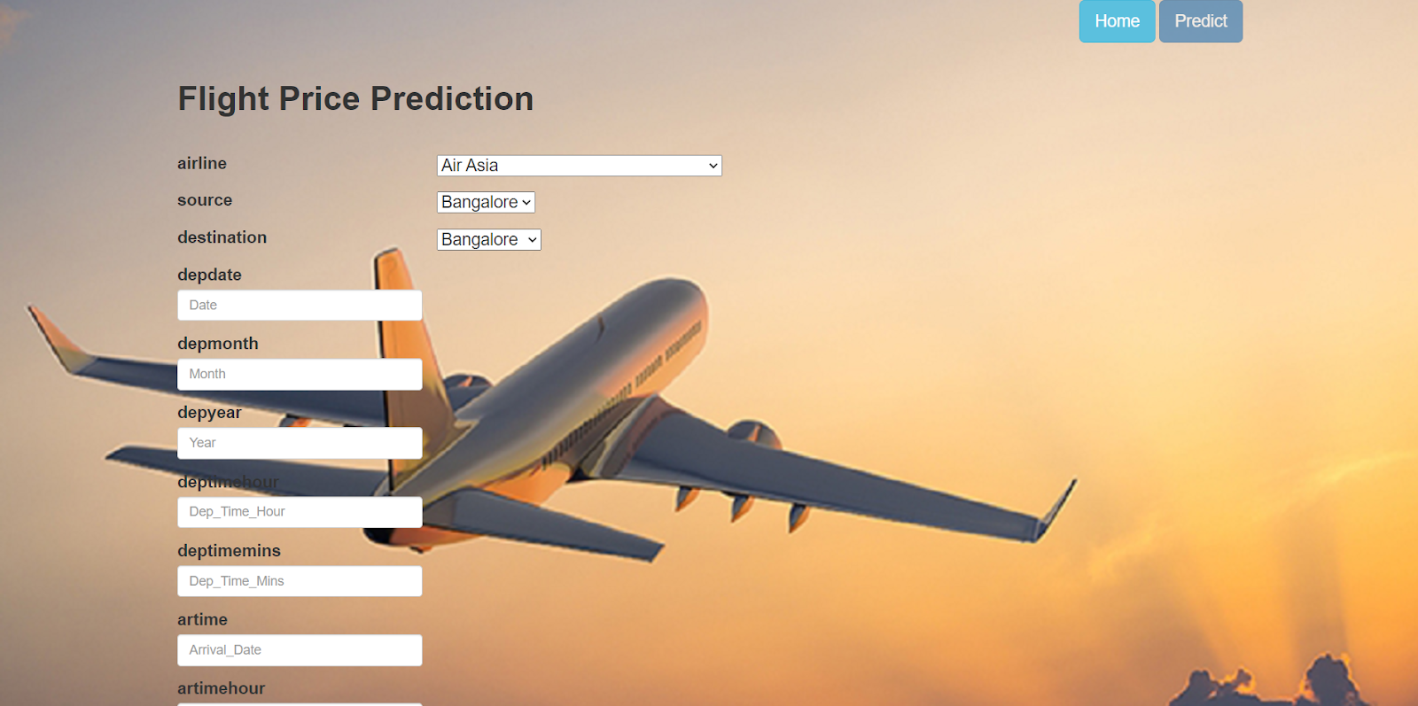

.ADVANTAGES AND DISADVANTAGES ADVANTAGES

• Traveler get the fare prediction handy using which it’s easy to decide the airlines

. • Saves time in searching / deciding for airlines.

DISADVANTAGES

• Impro per data will result in incorrect fare predictions.

APPLICATIONS

• Airfare tracking

• make traveling easier

• flight search and airfare prediction

• Airfare tracking and hotel booking

.CONCLUSION

hyper-parameters to get the optimum design for airline price prediction. In this project is to forecast the average flight price at the business segment level. We used training data to train the training data and test data to test it. These records were used to extract a number of characteristics. Our suggested model can estimate the quarterly average flight price using attribute selection strategies.To the highest possible standard, much prior studies into flight price prediction using the large dataset depended on standard statistical approaches, which have their own limitations in terms of underlying issue estimates and hypotheses. To our knowledge, no other research have included statistics from holidays, celebrations, stock market price fluctuations, depression, fuel price, and socioeconomic information to estimate the air transport market sector; nonetheless, there are numerous restrictions.As example, neither of the databases provide precise information about ticket revenue, including such departing and arrival times and days of the week. This framework may be expanded in the future to also include airline tickets payment details, that can offer more detail about each area, such as timestamp of entry and exit, seat placement, covered auxiliary items, and so on. By merging such data, it is feasible to create a more robust and complete daily and even daily flight price forecast model. Furthermore, a huge surge of big commuters triggered by some unique events might alter flight costs in a market sector. Thus, incident data will be gathered from a variety of sources, including social media sites and media organizations, to supplement our forecasting models. We will also examine specific technological Models, such as Deeper Learning methods, meanwhile striving to enhance existing models by modifying their

.FUTURESCOPE

• More routes can be added and the same analysis can be expanded to major airports and travel routes in india.

• The analysis can be done by increasing the data points and increasing the historical data used. That will train the model better giving better accuracies and more savings.

• More rules can be added in the rule based learning based on our understanding of the industry, also incorporating the offer periods given by the airlines

. • Developing a more user friendly interface for various routes giving more flexibility to the users.

.BIBILOGRAPHY

[1] K. Tziridis, T. Kalampokas, G. A. Papakostas and K. I. Diamantaras, Airfare prices prediction using machine learning techniques, 2017 25th European Signal Processing Conference (EUSIPCO), Kos, Greece, 2017, pp. 1036-1039, https://doi.org/10.23919/EUSIPCO.2017.8081365 . [2] Juhar Ahmed Abdella, Nazar Zaki, Khaled Shuaib, Fahad Khan, Airline ticket price and demand prediction: A survey, Journal of King Saud University - Computer and Information Sciences, 2019, ISSN 1319-1578, https://doi.org/10.1016/j.jksuci.2019.02.001 [3] Martijn Brons, Eric Pels, Peter Nijkamp, Piet Rietveld, Price elasticities of demand for passenger air travel: a meta-analysis, Journal of Air Transport Management, Volume 8, Issue 3, 2002, Pages 165-175, ISSN 0969- 6997, https://doi.org/10.1016/S0969-6997(01)00050-3 . [4] Silke J. Forbes, The effect of air traffic delays on airline prices, International Journal of Industrial Organization, Volume 26, Issue 5, 2008, Pages 1218-1232, ISSN 0167-7187, https://doi.org/10.1016/j.ijindorg.2007.12.004 .

APPENDIX

A Source Code of Flask:

from flask import Flask, render_template, request

import numpy as np

import pickle

import pandas as pd

model = pickle.load(open(r"D:\flight\flask\model1.pkl",'rb'))

app = Flask(__name__)

@app.route("/")

def about(): return render_template('home.html')

@app.route("/predict") def home1():

return render_template('predict.html')

@app.route("/pred", methods=['POST','GET'])

def predict(): x = [[int(x) for x in request.form.values()]]

print(x) x = np.array(x) print(x.shape)

print(x) pred = model.predict(x) p

rint(pred[0]) return render_template('submit.html', prediction_text=pred[0])

if __name__ == "__main__":

app.run(debug=False)